Project Requirements Document

# 

**Overview 4**

**Account types and requirements 5**

Personal Account 5

ID Requirements: 5

Minimum Opening Balance 5

Charges 5

Features 5

Account Limit 5

ISA Account 5

Reference 5

Benefits 5

Account Limit 6

ID Requirements 6

Exclusions 6

Types of ISAs: 6

Features 6

Account Limit 7

Business Account 7

ID Requirements 7

Exclusions 7

Features 7

Account Limit 7

**Functional Requirements 8**

Personal Account 8

ISA Account 8

Business Account 8

Authentication 9

Transaction Management 9

Menu System 9

Help System 9

Data Validation 9

**Non-Functional Requirements 10**

Performance 10

Scalability 10

Reliability 10

Security 10

Usability 10

Compliance 10

Maintainability 11

Backup and Recovery 11

**Checklist 12**

Personal Account 12

ISA Account 12

Business Account 12

Authentication and Authorization 13

Transaction Management 13

Menu System 13

Help System 13

Data Validation 13

Security 13

Compliance 14

Usability 14

Additional Methods Based on Questions for Trevor 14

**Missing Information 15**

**Diagrams 16**

Use Case 16

Class Diagram 17

# 

# Overview

Develop a C# application for Acme Bank that allows tellers to access customer accounts. The application will manage three types of accounts: Personal Account, ISA Account, and Business Account. The deadline for this task is **19th July 2024**.

# Account types and requirements

## Personal Account

### ID Requirements:

* Photo ID (e.g., passport, driving licence)
* Address-based ID (e.g., utility bill, council letter)

### Minimum Opening Balance

£1 (GBP)

## **Charges**

* No charges for owning an account
* Potential charges if the account is overdrawn

### Features

* Direct debits
* Standing orders

### Account Limit

A customer **can have multiple** personal accounts.

## ISA Account

### Reference

Details found at Individual Savings Accounts (ISAs): <https://www.gov.uk/individual-savings-accounts>

### Benefits

* Annual APR of 2.75% on the average annual balance.

### Account Limit

* A customer can have only one ISA account.
* Business Account
* In the 2024 to 2025 tax year, the maximum amount a customer can save in ISAs is £20,000.

### ID Requirements

* Proof and details of an existing business (e.g., business registration documents).
* Must be 18 or over to open an ISA.
* Must be resident in the UK or a member of the armed forces or a Crown servant (or their spouse/civil partner) if not residing in the UK.

### Exclusions

* Enterprises, PLCs, charities, public sector businesses (handled by another department).

### Types of ISAs:

* Cash ISA
* Stocks and shares ISA
* Innovative finance ISA
* Lifetime ISA (specific requirements: must be under 40 to open, only for individuals born between 6 April 2006 and 5 April 2008, can open one cash ISA before turning 18)

**No need to differentiate between them**

### Features

* Business cheque book (on request)
* Debit/credit cards
* Overdraft facility
* International trading
* Access to loans
* Annual Charge: £120 (GBP)

### Account Limit

A business **can only apply for one** account.

## Business Account

### ID Requirements

* Proof and details of an existing business (e.g., business registration documents).

## Exclusions

* Enterprises, PLCs, charities, public sector businesses (handled by another department).

### Features

* Business cheque book (on request)
* Debit/credit cards
* Overdraft facility
* International trading
* Access to loans
* Annual Charge: £120 (GBP)

### Account Limit

A business can **only apply for one** account.

# Functional Requirements

## Personal Account

* Customers must provide photo ID (passport, driving licence) and address-based ID (utility bill, council letter) when opening an account.
* A minimum opening balance of £1 (GBP) is required.
* Direct debits and standing orders can be set up.
* Customers can have multiple personal accounts.
* No charges for maintaining the account, but charges may apply if the account is overdrawn.

## ISA Account

* Customers can only have one ISA account.
* The account provides an annual APR of 2.75% on the average annual balance.
* Validate that the customer is 18 or over (for all ISAs except Lifetime ISA, which requires the customer to be under 40).
* Ensure the customer is either a UK resident or qualifies under specific criteria (armed forces, Crown servant, or their spouse/civil partner).
* Verify that the customer does not exceed the £20,000 annual savings limit across all ISA accounts.
* Implement checks to ensure that a customer can only have one ISA of each type (e.g., one cash ISA, one stocks and shares ISA, etc.).
* Include functionality for handling ISA withdrawals and the conditions under which they are allowed.

## Business Account

* Customers must provide proof and details of an existing business (e.g., business registration documents).
* Enterprises, PLCs, charities, and public sector businesses are excluded.
* Account features include a business cheque book (on request), debit/credit cards, overdraft facility, international trading, and access to loans.
* An annual charge of £120 (GBP) applies.
* Businesses can only have one business account.
* Authentication and Authorization

## Authentication

* Implement a method to authenticate customers to access their accounts.
* Ensure only authorised tellers can access customer account information.

## Transaction Management

* Support for common transactions such as deposits, withdrawals, and transfers between accounts.
* Ensure validation and error handling for all transactions.

## Menu System

* Implement a simple menu system for tellers to navigate through the application.
* Provide options to view, add, edit, and delete accounts.
* This will be done as a console application

## Help System

* Integrate a help system to assist tellers in using the application.
* The help system should provide context-sensitive help linked to the current task.

## Data Validation

* Ensure all input data is validated to prevent incorrect or malicious data entries.
* Provide clear error messages for invalid inputs.

# 

# Non-Functional Requirements

## Performance

* What are the acceptable performance metrics?
* Are there specific testing requirements?

## Scalability

* Are there any plans for expanding the types of accounts or services in the future e.g. does the programme need to account for scalability concerns?
* Ensure the architecture supports easy addition of new features and account types.

## Reliability

* Implement error handling to ensure the system does not crash due to invalid inputs or other errors.

## Security

* Are there any additional security measures required (e.g., encryption, logging)?
* Implement secure authentication mechanisms to protect customer data.
* Encrypt sensitive data to prevent unauthorized access. (if possible)
* Conduct regular security audits and updates.

## Usability

* The menu system should be intuitive and easy to navigate for tellers.
* Provide comprehensive documentation and training materials for new tellers.
* Are there specific usability standards or guidelines to follow?

## Compliance

* Ensure the application complies with all relevant banking regulations and guidelines.
* Regularly update the system to adhere to new regulations and standards.

## Maintainability

* The codebase should be well-documented and follow standard coding practices.
* Implement modular design to facilitate easier maintenance and updates.

## Backup and Recovery

* Implement regular data backup procedures to prevent data loss.
* Ensure the system can recover quickly from failures or data corruption.

# Checklist

This is a checklist

## Personal Account

* **Method**: SetupDirectDebit
* **Method**: SetupStandingOrder
* **Method**: CheckOverdraft
* **Method**: ChargeOverdraftFees

## ISA Account

* **Method**: OpenISAAccount
  + Validate Age Requirement
  + Validate Residency Requirement
  + Ensure Single ISA Account Limit
  + Ensure Annual Savings Limit
* **Method**: CalculateISAInterest
  + Calculate annual APR of 2.75%
* **Method**: HandleISAWithdrawals
* **Method**: CheckISAContributionLimit

## Business Account

* **Method**: OpenBusinessAccount
  + Validate Business Documents
* **Method**: RequestBusinessChequeBook
* **Method**: IssueDebitCreditCards
* **Method**: SetupOverdraft
* **Method**: SetupInternationalTrading
* **Method**: AccessBusinessLoans
* **Method**: ChargeAnnualFee

## Authentication and Authorization

* **Method**: AuthenticateCustomer
* **Method**: AuthorizeTeller

## Transaction Management

* **Method**: Deposit
* **Method**: Withdraw
* **Method**: TransferFunds

This applies to all!

## Menu System

* **Method**: DisplayMenu
* **Method**: NavigateToAddAccount
* **Method**: NavigateToEditAccount
* **Method**: NavigateToDeleteAccount
* **Method**: ViewAccountDetails

## Help System

* **Method**: DisplayHelp
  + Give relevant FAQ and Guidence

## Data Validation

* **Method**: ValidateInputData
* **Method**: DisplayErrorMessage

## Security

* **Method**: EncryptSensitiveData
* **Method**: RegularSecurityAudit?

## Compliance

* Ensure Regulatory Compliance
* Update System For New Regulations

## Usability

* Provide User Documentation

## Additional Methods Based on Questions for Trevor

Implement Transaction Limits

Verify ID functions

Calculate APR

Handle PIN Entry

# 

# Missing Information

* Are there specific usability standards or guidelines to follow?
* Are there any additional security measures required (e.g., encryption, logging)?
* What are the acceptable performance metrics?
* Are there specific testing requirements?
* What types of testing should be performed (e.g., unit testing, integration testing, user acceptance testing)?
* Are there specific tools or frameworks preferred for testing?
* Should the ISA be one generic ISA or handle multiple ISA accounts (Lifetime - Stock and Share)?
* Are there any specific rules or limits for transactions?
* What are the daily, monthly, or transaction-specific limits for deposits, withdrawals, and transfers?
* Are there any specific validation rules for transactions (e.g., overdraft limits, account balance checks)?
* Are there specific requirements for password policies and strength?

# Diagrams

## Use Case

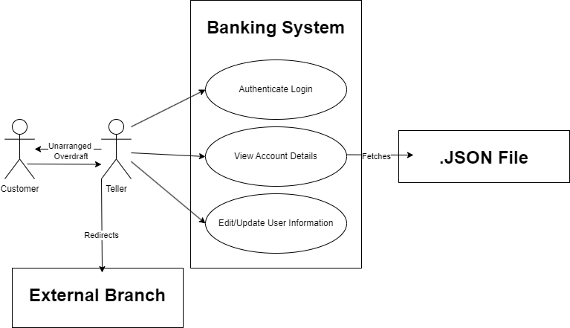

## Class Diagram

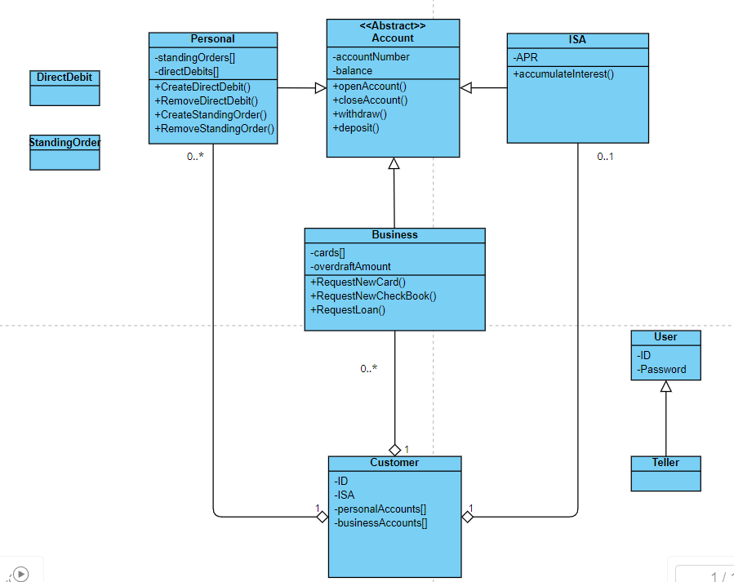

## Personas

